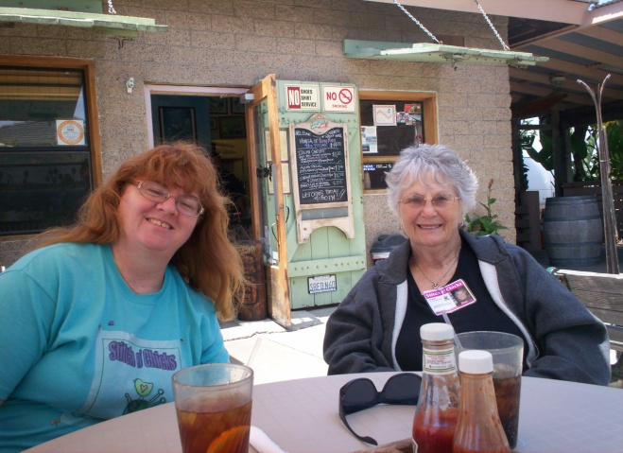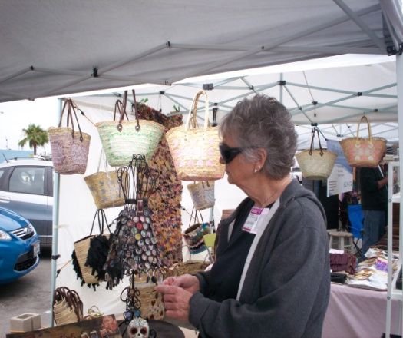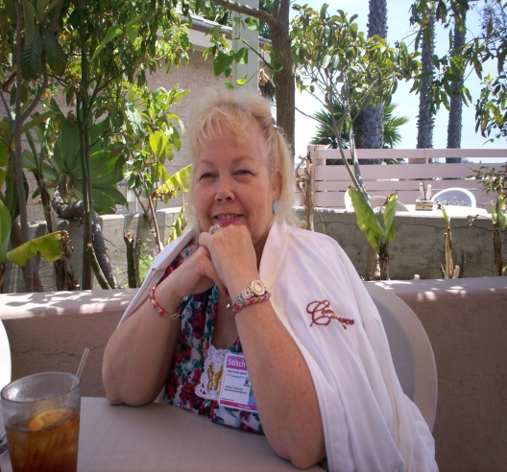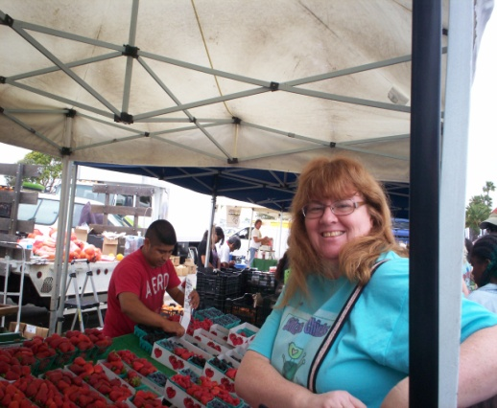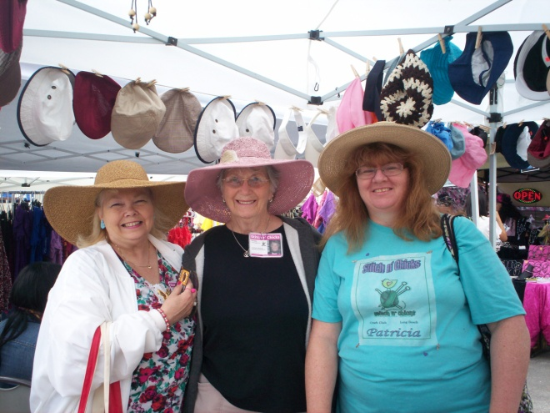

Craft Fair & Farmer’s Market

**June 3rd, 2012**

Long Beach Marina

Pat, Patricia, & Debb roamed the fair and found some unique crafts, there were a lot of vendors and lots of fruits, vegetables, and stands with plants. It really grew! The lunch we had planned had to be changed since the original restaurant; “Schooner or Lat’er” had a 2 hour wait!! Wow!! So we headed on over to “River’s End” and ate right on the sand. ☺ Fun day!!!

Stitch n’ Chicks • • stitchnchicks@msn.com • [www.stitchnchicks.weebly.com](http://www.stitchnchicks.weebly.com)

**Debb, Pat & Patricia try on hats @ “The Hat Lady’s booth**