**SnC Charity:**

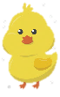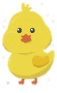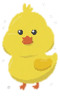Image result for chickens in bath clipart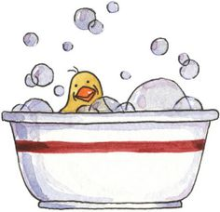**Just Print out and cut your labels; add your name on the “Made by” line; to secure around your washcloth, tape or staple the label

**100% Cotton Washcloth**

**This gift was handmade just for you by *Stitch n’ Chicks***



[stitchnchicks@msn.com](mailto:stitchnchicks@msn.com)

[www.stitchnchicks.weebly.com](http://www.stitchnchicks.weebly.com)

(562)756-1556

********

Made by:_________________

**100% Cotton Washcloth**

**This gift was handmade just for you by *Stitch n’ Chicks***